CASE STUDY ON FRACTION

Arati has a hobby of gardening. She has taken a bank loan to initiate floriculture in her 200 sq m area of vacant land. She wants to plant rose in one half of the area. The remaining field she wants to use for marigold, sunflower, tulips and hibiscus using equal area for each flower of that field.
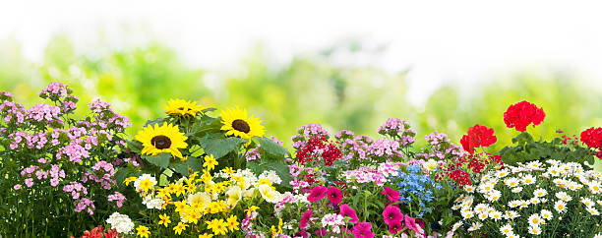

Based on the above information answer the following questions.
- Find the area to be used for planting rose flower.
- Find the fraction of the total area being used for planting sunflower and marigold.
- Find 3 equivalents fractions of the fraction of area where hibiscus was planted.
- Arati has decided to distribute 200 roses among 50 friends of her,what part of total roses each of her friends will get?
- Find the total area of land which is used to plant rose,marigold and hibiscus.

HOTS
- What fraction of a straight angle is a right angle?
- The food we eat remains in the stomach for 10 hours. What fraction of three days does it remain here?
- A does 1/5 part of a work, B does ½ of a work and C does the remaining part. Find the part done by C.
- T/F. The sum of two fractions is always a fraction.
- What fraction of a year is 2 months?

